11.86: a) Solving Eq. (11.10) for 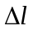 and using the weight for F,
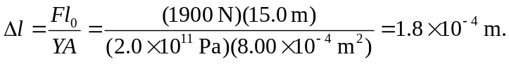
b) From Example 5.21, the force that each car exerts on the cable is 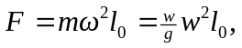 and so

